Assignment -4

|  |  |
| --- | --- |
| Date | 04 November 2022 |
| Team ID | PNT2022TMID27179 |
| Project Name | Smart Farmer-IoT Enabled smart Farming Application |
| Maximum Marks | 2 Marks |

Question-1:

*Write code and connections in wokwi for ultrasonic. Whenever distance is less than 100 cms send “alert” to*

*IBM cloud and display in device recent events.*

**Solution:**

#define ECHO_PIN 2

#define TRIG_PIN 3

#define organization = “fkxdqs”

#define device Type = “Arduino”

#define deviceId = “1200”

#define authMethod = “use-token-auth”

#define authToken = “00000000”

void setup ()

{

Serial.begin (9600);

pinMode (TRIG_PIN, OUTPUT);

pinMode (ECHO_PIN, INPUT);

}

float readDistanceCM ()

{

Digital Write (TRIG_PIN, LOW);

delay Microseconds (2);

digital Write (TRIG_PIN, HIGH);

delay Microseconds (10);

digital Write (TRIG_PIN, LOW);

int duration = pulseIn (ECHO_PIN, HIGH);

return duration * 0.034 / 2;

}

void loop ()

{

float distance = readDistanceCM ();

if (distance <= 100)

{

Serial.println("person detected ");

}

Else

{

Serial.print("Measured distance: ");

Serial.println(readDistanceCM ());

}

delay (1000);

}

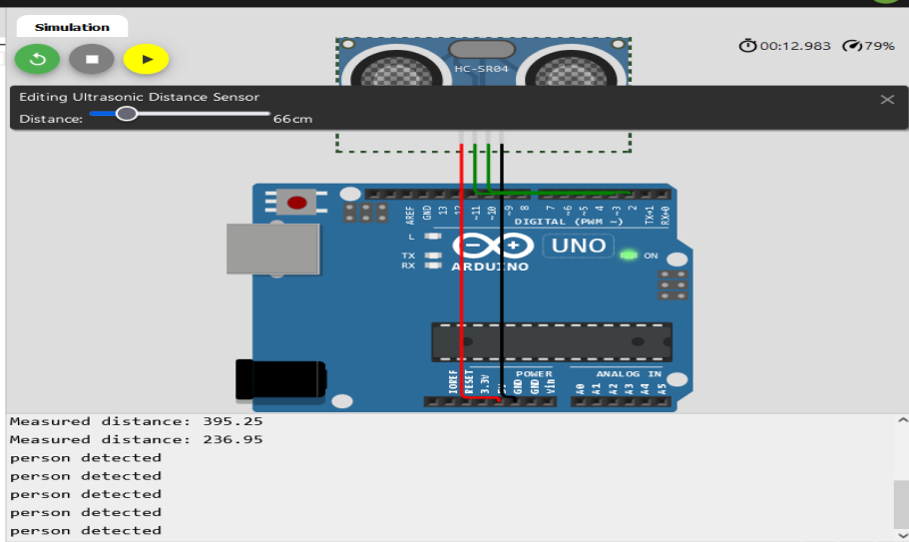

Wokwi Link: <https://wokwi.com/projects/346567349532361298>

IBM Cloud

Device Recent Events

